| text divider |
| --- |
|  |





# Executive summary (200 Words)

1st Paragraph – Subject and problem in 2 statements

2nd Paragraph – How the project tackles the problem

3rd Paragraph – Key results, with numerical support

4th Paragraph – your take home message

# Table of Contents

# Introduction

## Problem Statement

Understanding future health trajectories and causes is crucial for long-term investment and policy execution. This research offers the prediction of life expectancy of a person given the essential parameters such as cause of death, all-cause mortality, socioeconomic, genetic, and environmental factors such as age, gender, environment, medical history, lifestyle choices and ethnicity – 38 causes of death - 193 countries and territories from 1990 to 2019.

## Rationale

One of the most important indicators for evaluating the health of a population is life expectancy, which is used by numerous international organizations including the UN and World Bank.  It is an overall indicator of community health. Predictions of life expectancy may be advantageous to people, healthcare professionals, and governments. For instance, they would increase people's awareness of their overall health and how it changes over time. They might be inspired by this to adopt a healthier lifestyle. Predictions may help governments more effectively distribute scarce resources like financial support for social welfare programmes and health care to people and regions with larger needs. On one hand, it may be useful for policy making, and help optimise an individual's health or the services they receive while on the other hand, it may have benefits for optimising an individual's health or the services they receive. There are many applications for it in the financial world as well, including life insurance, pension planning, and Social Security benefits.

By examining a few potentially correlated factors to life expectancy, such as demographic factors, income composition, mortality rates, immunization rates, and educational attainment, among others, this report will examine the growth in life expectancy throughout the world over the past 30 years as well as the inequality gap among the world's nations.

Alongside industrialization and the modernization of the new worlds, life expectancy had risen. The average life expectancy today is 84 years, compared to an estimated average life expectancy of 30 years for our predecessors in the pre-modern era.

The increase in life expectancy has been driven by advances in technology, society, and lifestyle. As a result, there is now a significant gap in average life expectancy between nations, each of which has seen various effects of modernization and technological growth. Findings from the analysis shows life expectancy ranges from 68 years in developing countries to 78 years in developed countries, a surprising gap difference of 10 years.

The type and quantity of data that are available will be crucial for accuracy. The WHO and World Bank data repository would be used for a large portion of this. Through this study, we hope to analyse and depict the linear relationship between the predictor factors and our goal variable—life expectancy—that exists between them.

## Project aim and objectives

The aim of the project was to explore how different factors impact the life expectancy of an individual.

The following questions were posed in order to support the project's goal:

1. What are the predicting variables affecting life expectancy?
2. What is the overall average life expectancy in most of the countries?
3. Do developed countries have more life expectancy than developing countries?
4. Does Life Expectancy have positive or negative correlation with eating habits, lifestyle, exercise, smoking, drinking alcohol etc.
5. Does population have any impact on life expectancy?
6. What is the impact of immunization on life expectancy?
7. What is the effect of different communicable/non-communicable diseases on life expectancy?
8. How do Infant and Adult mortality rates affect life expectancy?
9. How does traffic mortality affect life expectancy?
10. What is the influence of indirectly related factors such as GDP per capita on the expected life of a human?
11. How much do lifestyle choices such as drinking alcohol impact a person’s expected years of age?

To determine how each characteristic relates to a person's life expectancy, we shall do a correlation study. In order to estimate the possibility of Life Expectancy in various nations around the world by identifying factors that are both favourably and adversely affecting life expectancy, the objective of this research is to create a linear regression model and explore additional advanced regression approaches.

The following goals guided our efforts to address these queries:

1. Choosing appropriate dataset
2. Cleaning, Transforming and performing EDA to understand the trend
3. Feature Selection in order to reduce the complexity of the model
4. Model Training is performed in order to increase performance in solving a certain task
5. Model Validation in order to examine the performance of the model for new data or test data.

We show how various directly and indirectly related factors affect life expectancy using predictors such as Deaths – communicable/non-communicable, Road Injuries, Terrorism and many more, it is made worse when these are combined with other risks.

# Methodology (2000 Words)

The suggested approach is shown in Figure 1 as a flowchart.

NOTE: Flow chart of the approach

## Dataset Used

The sources are used to obtain data:

* World Bank Open Data (Life expectancy at birth, total (years), Mortality rate, infant (per 1,000 live births), Population, GDP per capita (current US$))
* Life expectancy WHO, (2000-2015): https://www.kaggle.com/datasets/kumarajarshi/life-expectancy-who
* Causes of Death - Our World in Data: https://www.kaggle.com/datasets/ivanchvez/causes-of-death-our-world-in-data

## Dataset Manipulation

Datasets such as Life Expectancy, Infant Mortality Rate, etc are extracted from the World Bank open data from 1990 to 2019. Then, these datasets are converted into a dataframe that is sorted by nation and year. A significant global study on the causes of illness and death was released in the medical journal The Lancet. The “Cause of Death” dataset provides the annual number of deaths due to certain communicable/non-communicable diseases and the deaths by unnatural causes. The primary dataset is then supplemented with these cause of death columns. The WHO Life Expectancy Dataset is only used to determine whether a country is classified as developed or developing.

## Handling the missing data

Handling the missing data is the initial stage in data cleaning. The primary goal is to eliminate features with missing values that account for more than half of all data points. These features include "Number of executions (Amnesty International)" and "Terrorism (deaths)," both of which have more than 50% of their values missing. While the mean of these columns is used to fill in the missing values of the GDP and infant mortality rate, the missing data points in the Population column are filled using a technique known as forwards fill, which propagates the last valid observation ahead. The bar graph below shows how many values are missing for various attributes.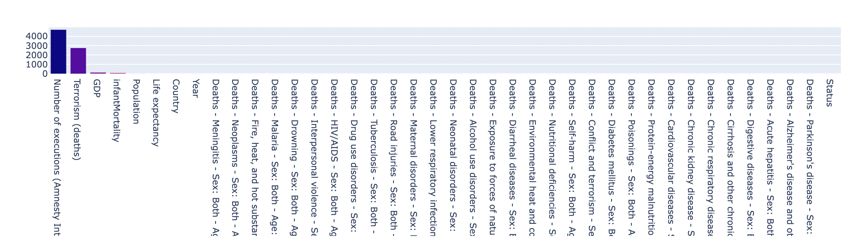

## Exploratory Data Analysis

### **4.1 World-wide Relationship between various attributes and year**

We began by creating a heatmap of the Life Expectancy for each country where the number represents the overall Life Expectancy and the colors represent how high or low the score is on a scale. The darker purple the country is the higher the numeric life expectancy for that country and the lighter the country is lower is their life expectancy. As we can see, Australia has a life expectancy of 81.5 representing the higher life expectancy.

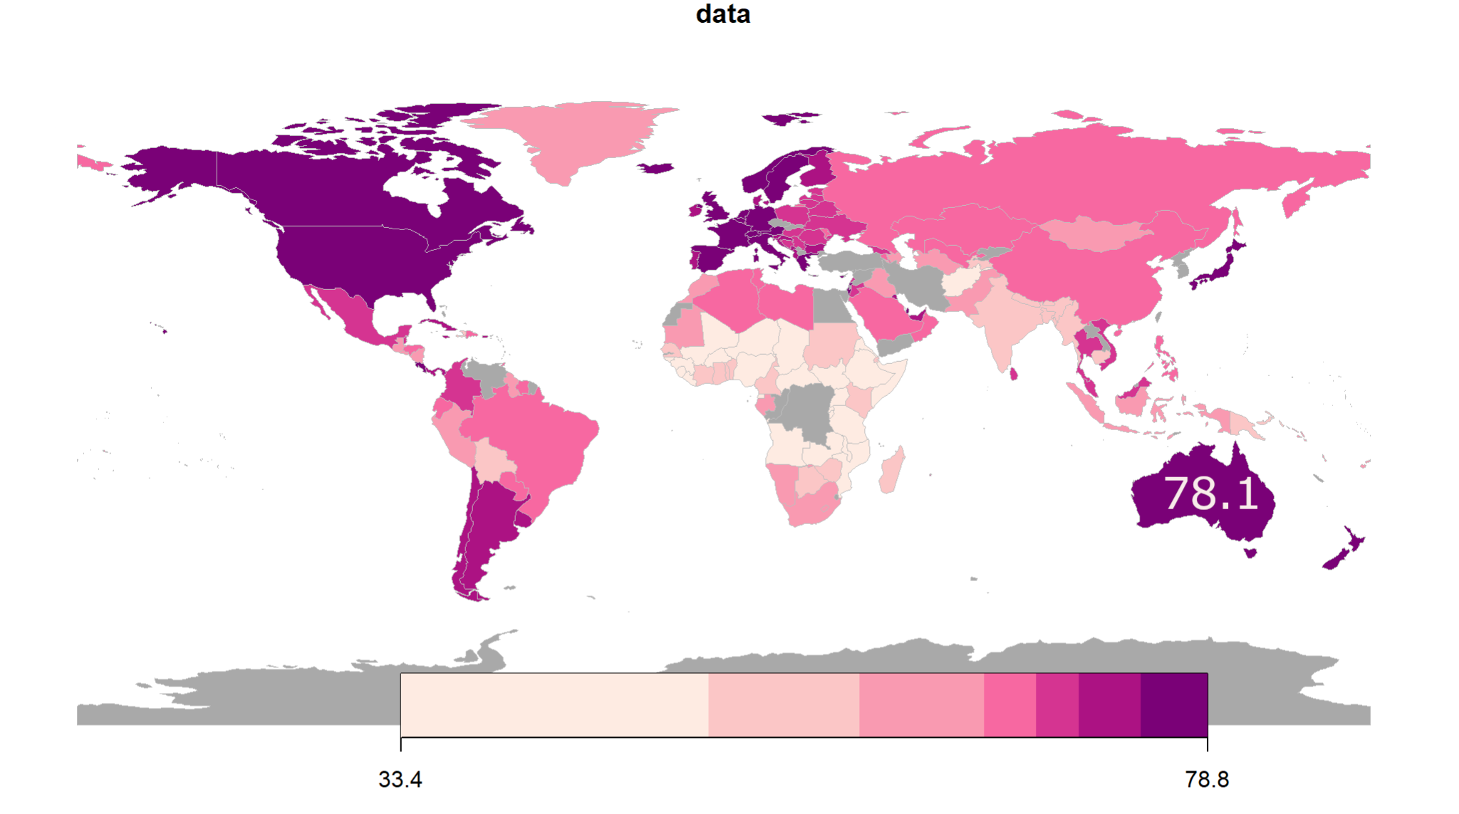

We can say that Life Expectancy varies widely by country. However, high and low scores are spread sporadically throughout the map, there is little correlation between the geographical location and life expectancy.

Finally we concluded that geographical location is not a strong indicator of Life Expectancy.

Moving forward, our next step was to identify the demographic, economic differences between the higher and lower countries to check the correlated features between them.

In order to identify trends in the dataset over a thirty-year period, it is first necessary to investigate the link between various variables with increasing year. Features like life expectancy, global population, and GDP per capita are seen to rise through time. Additionally, there has been a sharp rise in the number of HIV/AIDS mortality and traffic accidents, followed by a period of stability until reaching a peak and then a decline. Conversely, there has been a sharp decline in infant mortality, meningitis deaths, drowning deaths, etc.

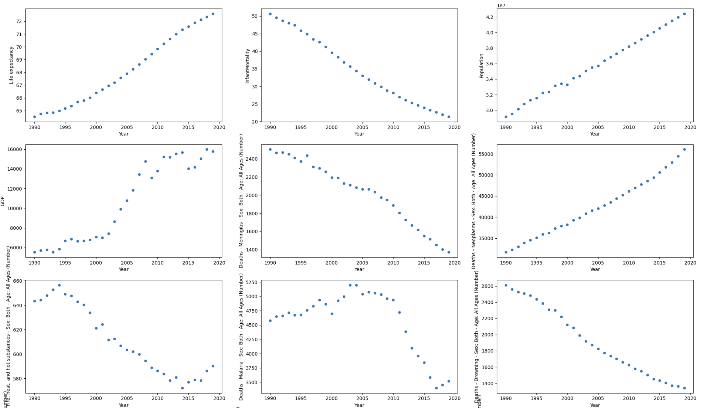

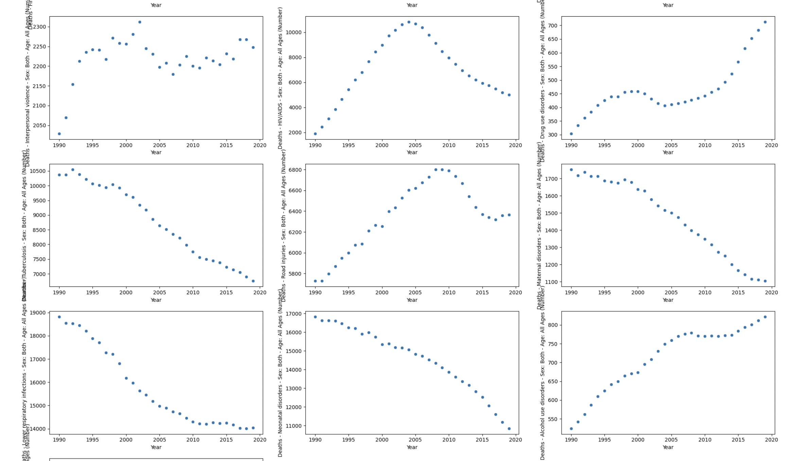 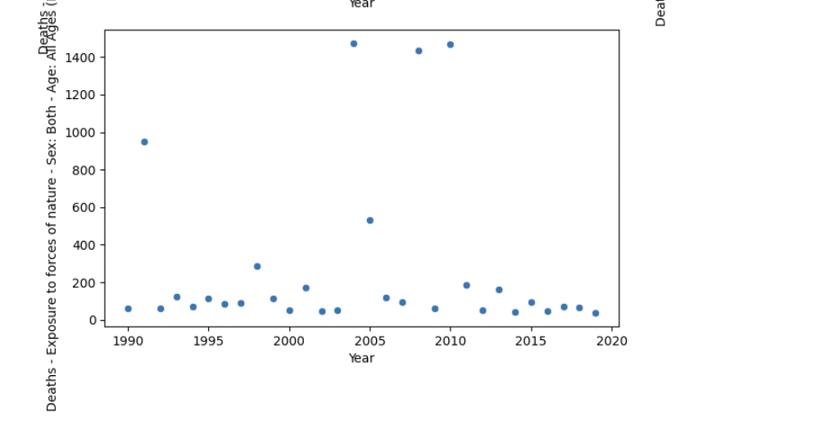

### **4.2 Correlation of Different attributes with each other**

To investigate the degree to which certain parameters affect life expectancy, a correlation heatmap is created for various features. This aids in the subsequent feature selection process, which helps to consider just those features that are highly associated and aids in increasing the robustness of the machine learning model.

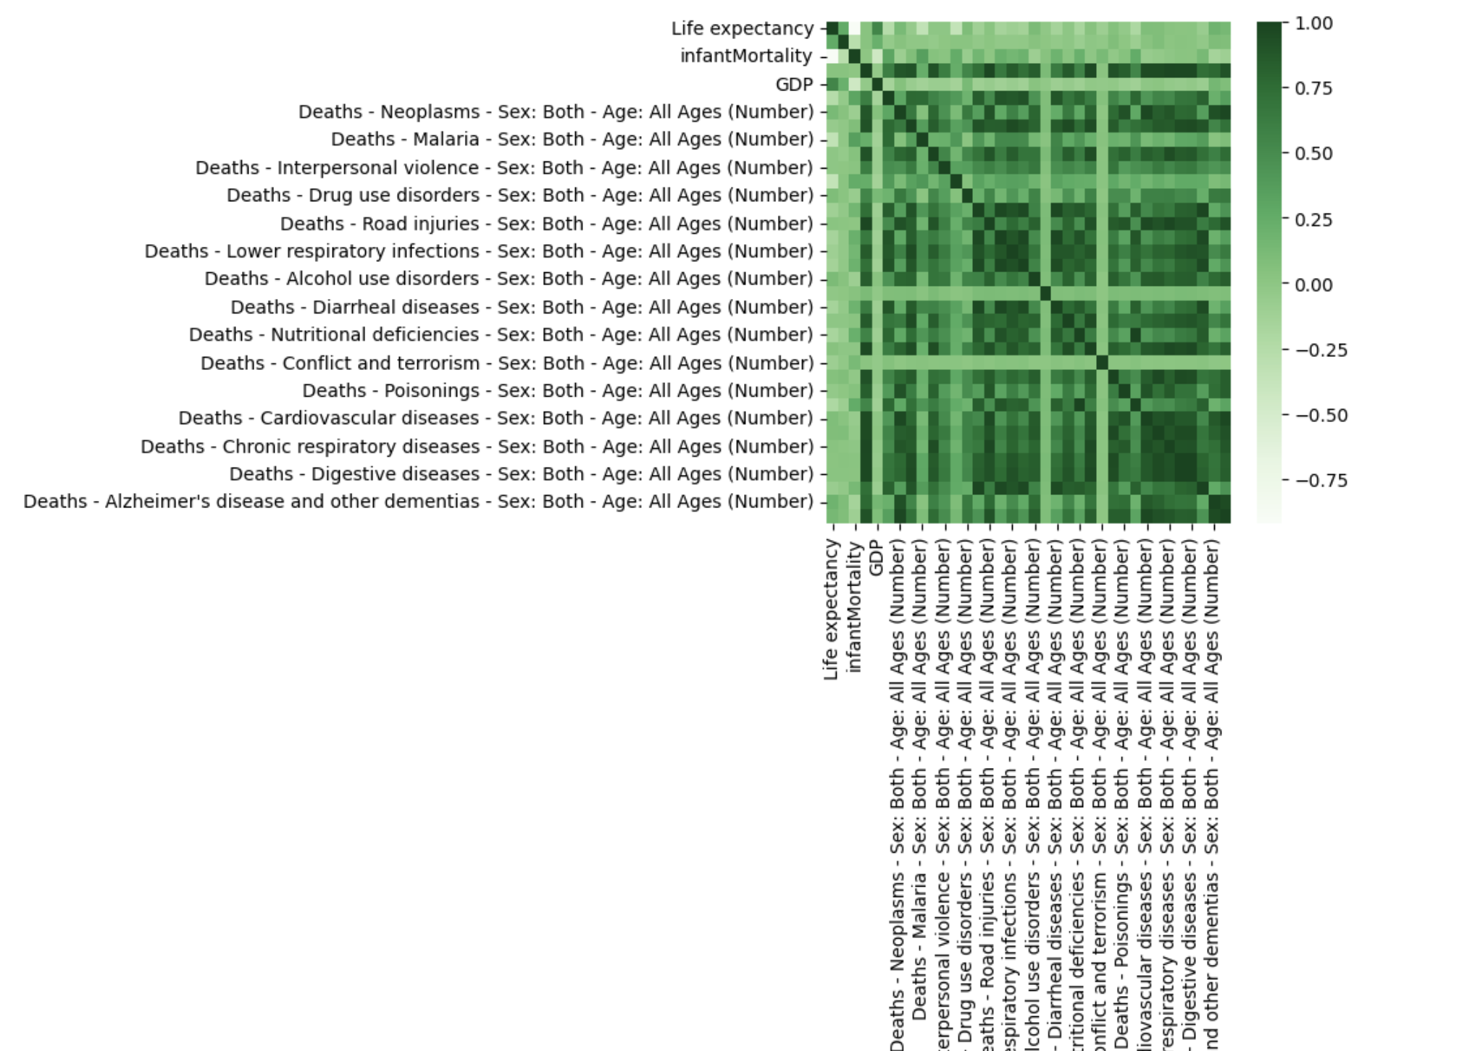

### **4.3 Distribution of life expectancy**

The distribution of life expectancy follows a left or negatively skewed bell curve. It implies that the curve's mean is likewise displaced to the peak's left side. 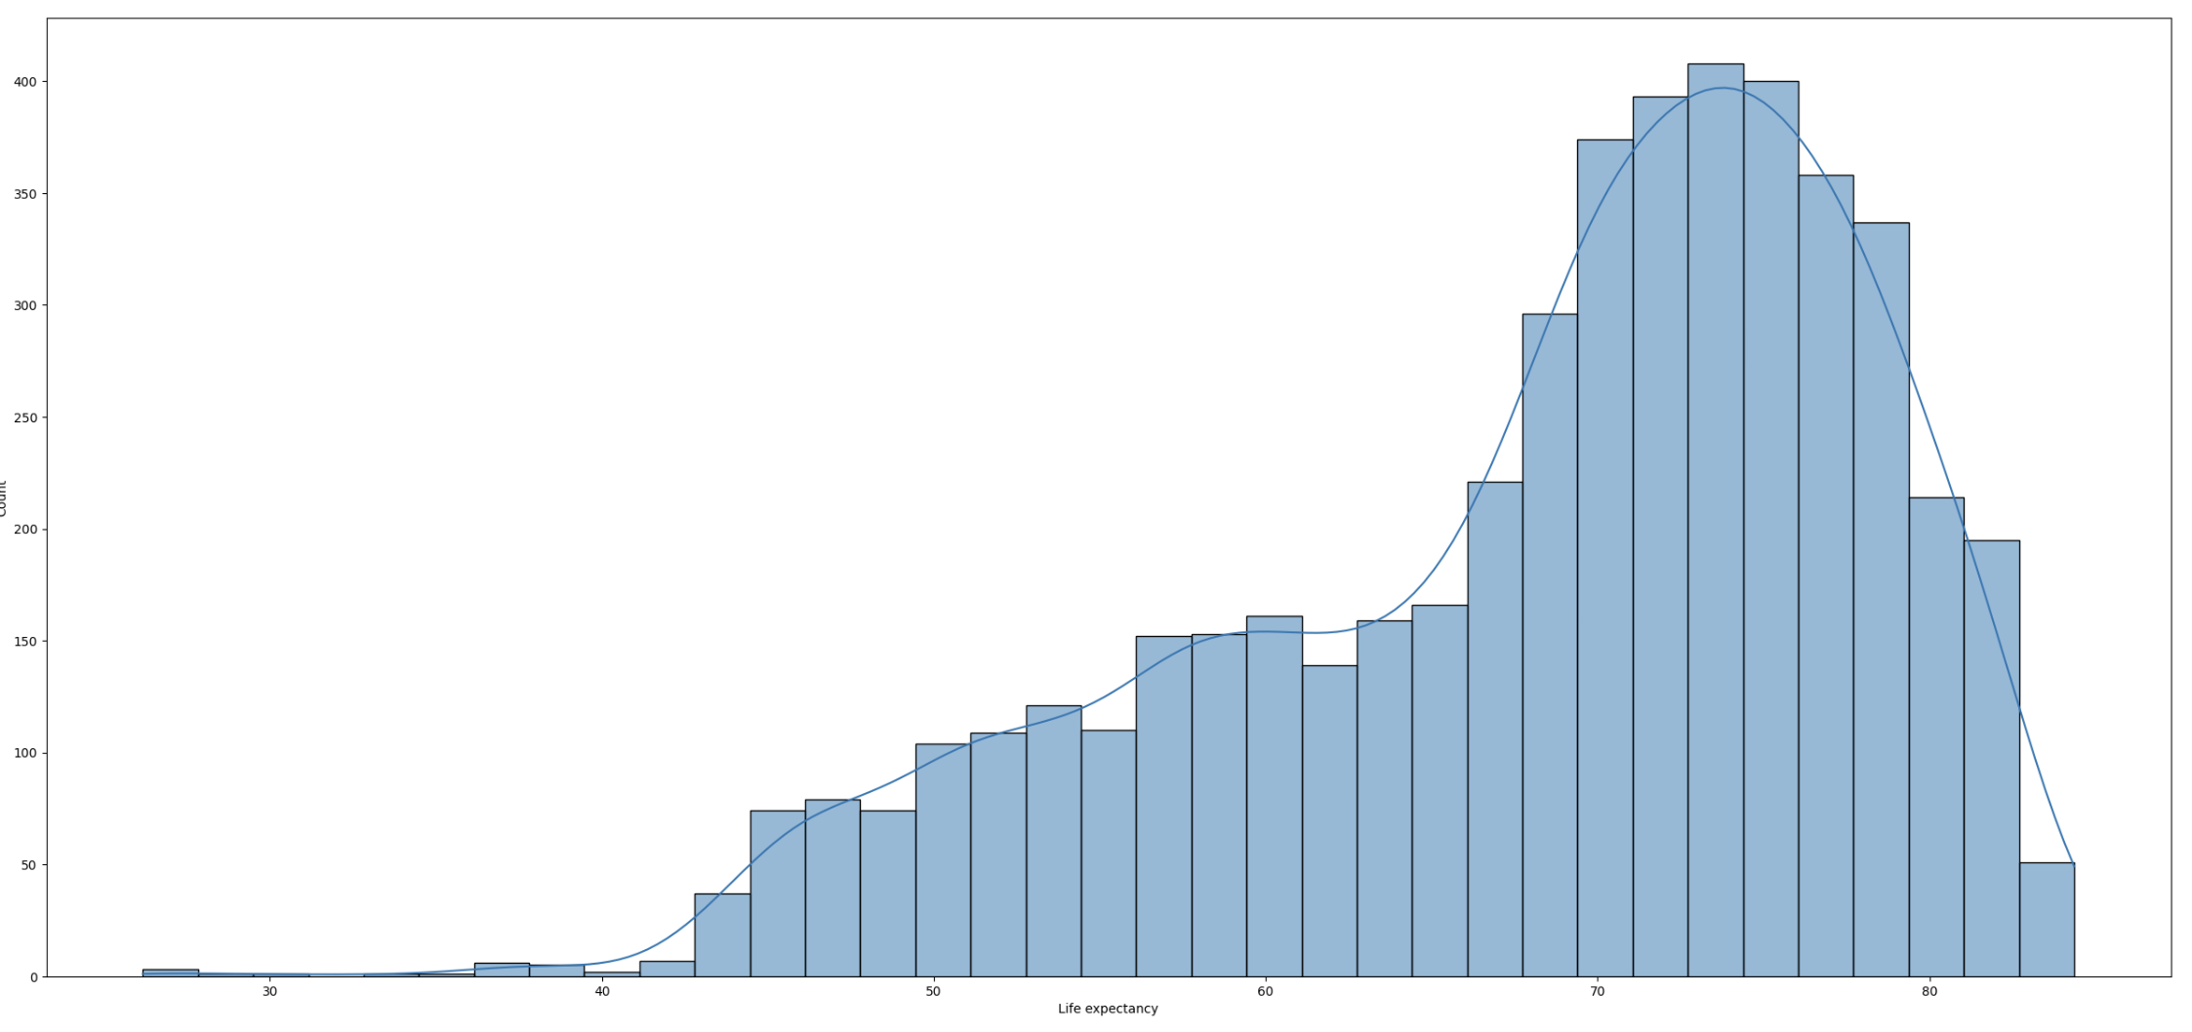

### **4.4 Effect of the development status of a country on life expectancy**

The impact of a country's level of development on life expectancy is addressed by the violin plot. With a median age of 78.2 years, it is evident that wealthy countries have a higher life expectancy than developing countries. The median age in developing countries is 68.5 years. Additionally, the box plot shows that the interquartile range for emerging nations is almost ten years greater than that for developed nations.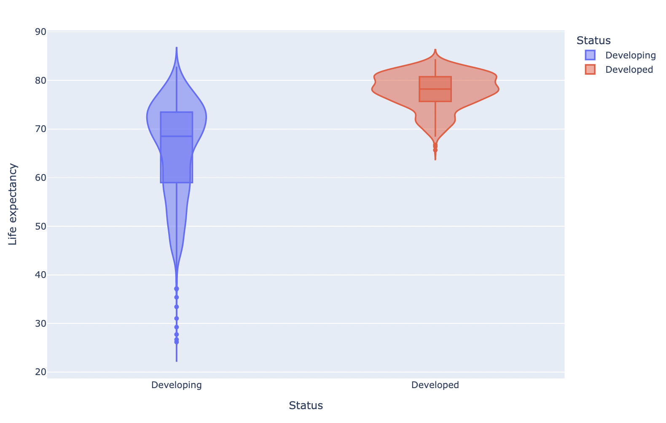

### **4.5 Country wise impact of various features on Life expectancy**

Scatter plots are used to study the effects of several parameters on life expectancy at the country level. The scatter plots for Australia over a 30-year period of data are shown below. Life expectancy has increased dramatically in recent years due to factors including rising GDP, neoplasm deaths, alcohol disorder fatalities, and more. The life expectancy in Australia also doesn't appear to be affected by things like malaria deaths or terrorism. The life expectancy in Australia has dramatically decreased as a result of factors such rising infant mortality and drowning deaths.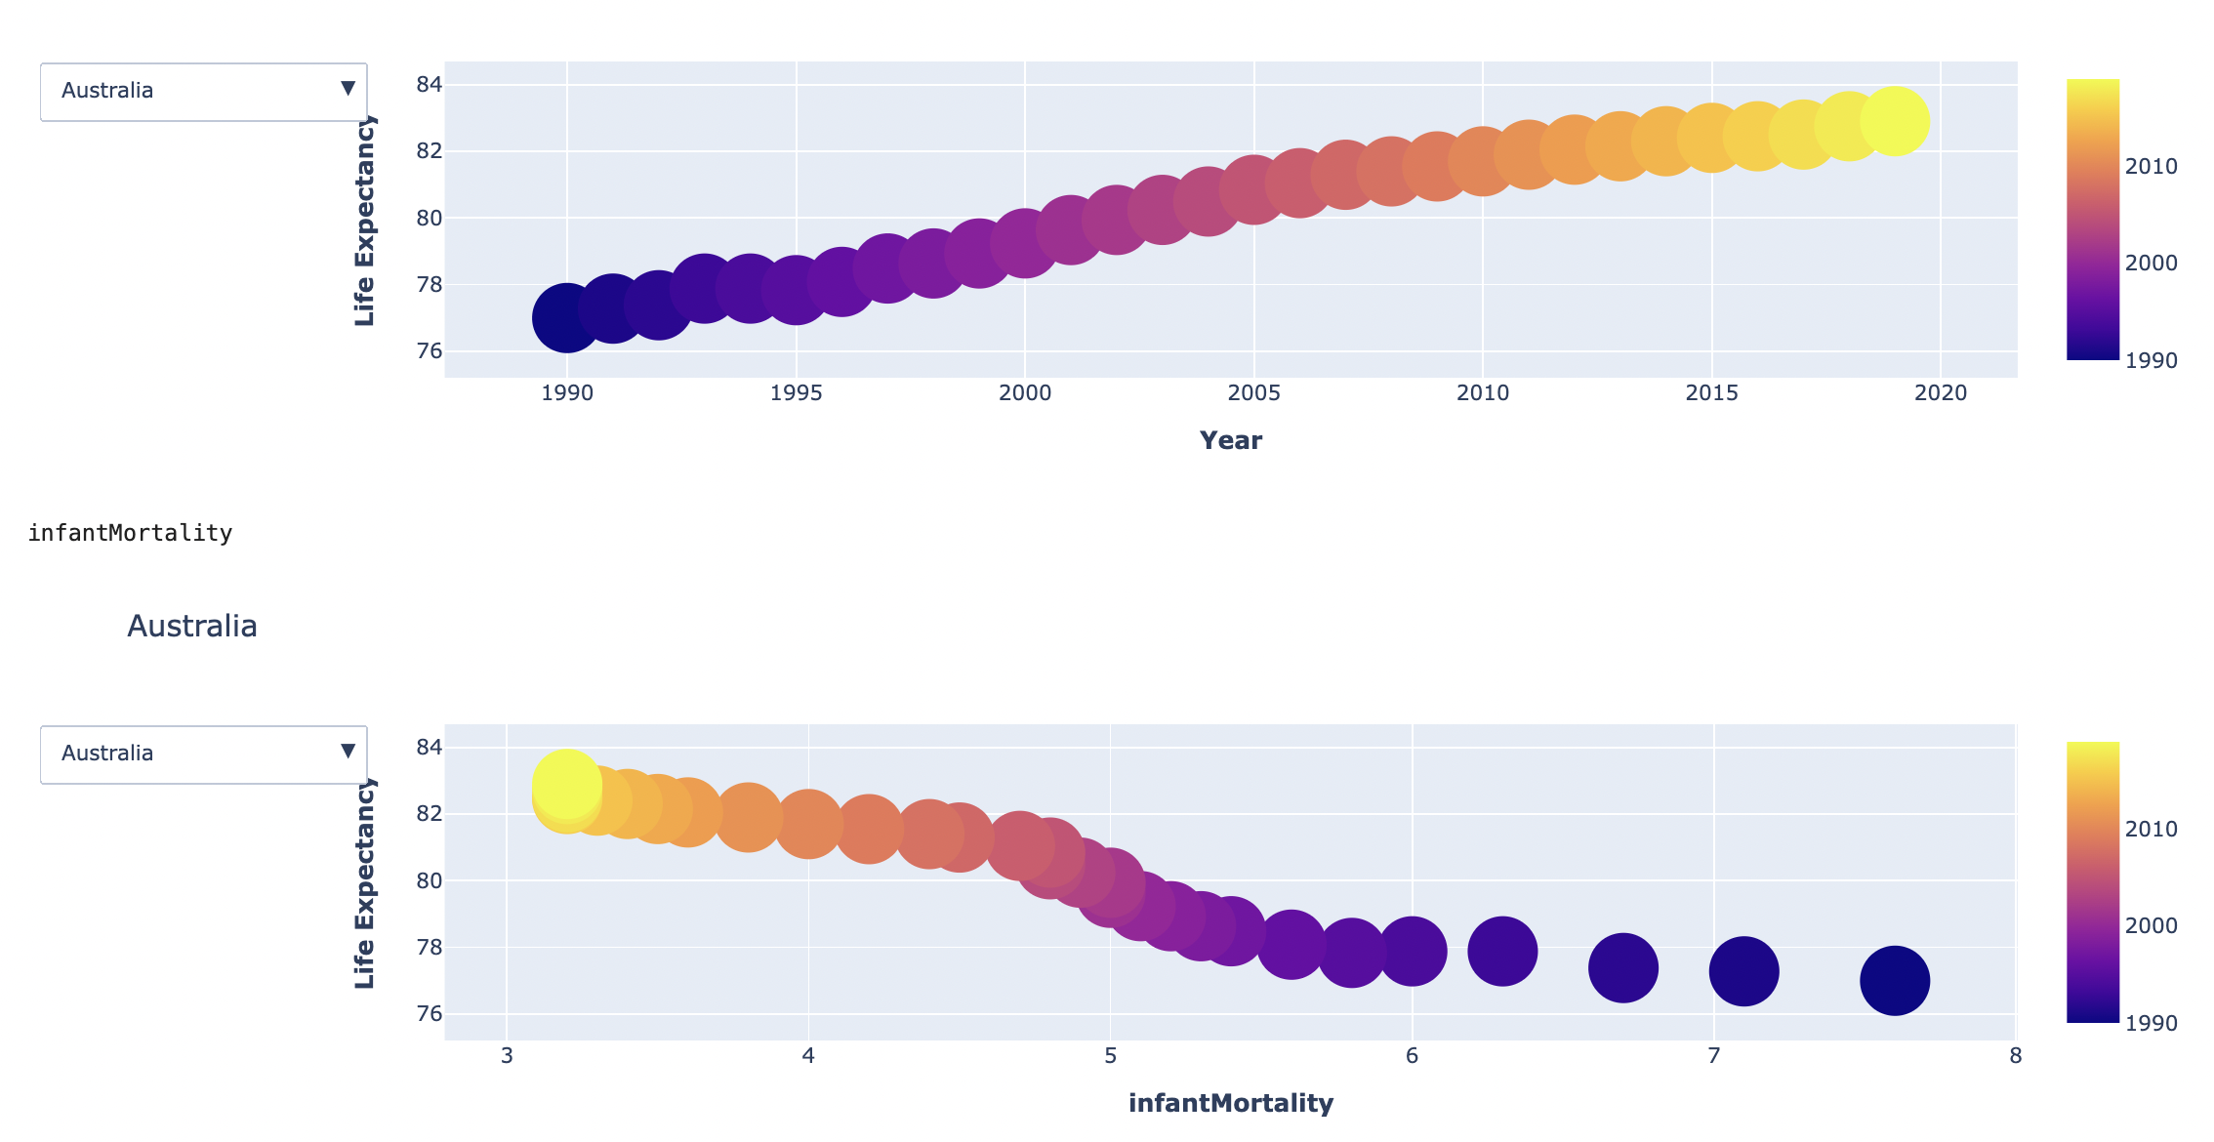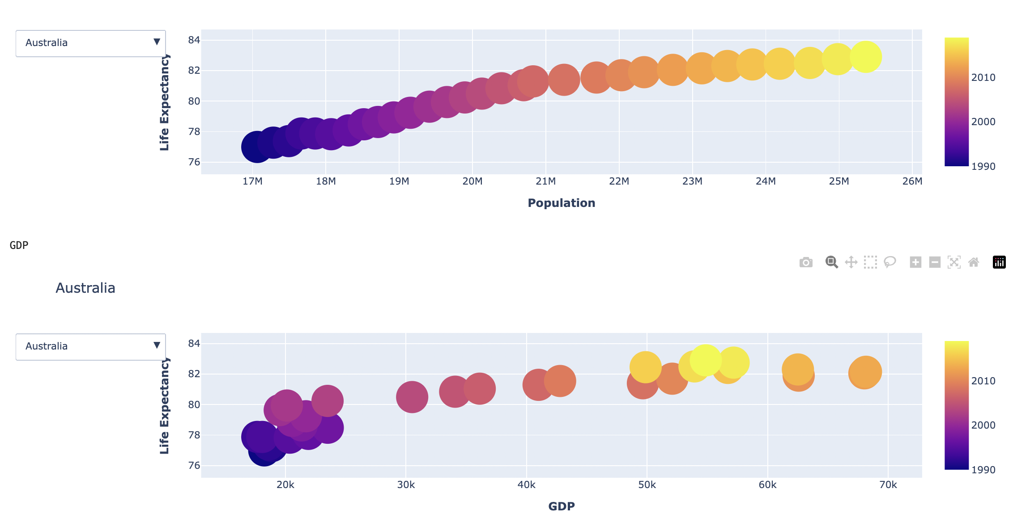

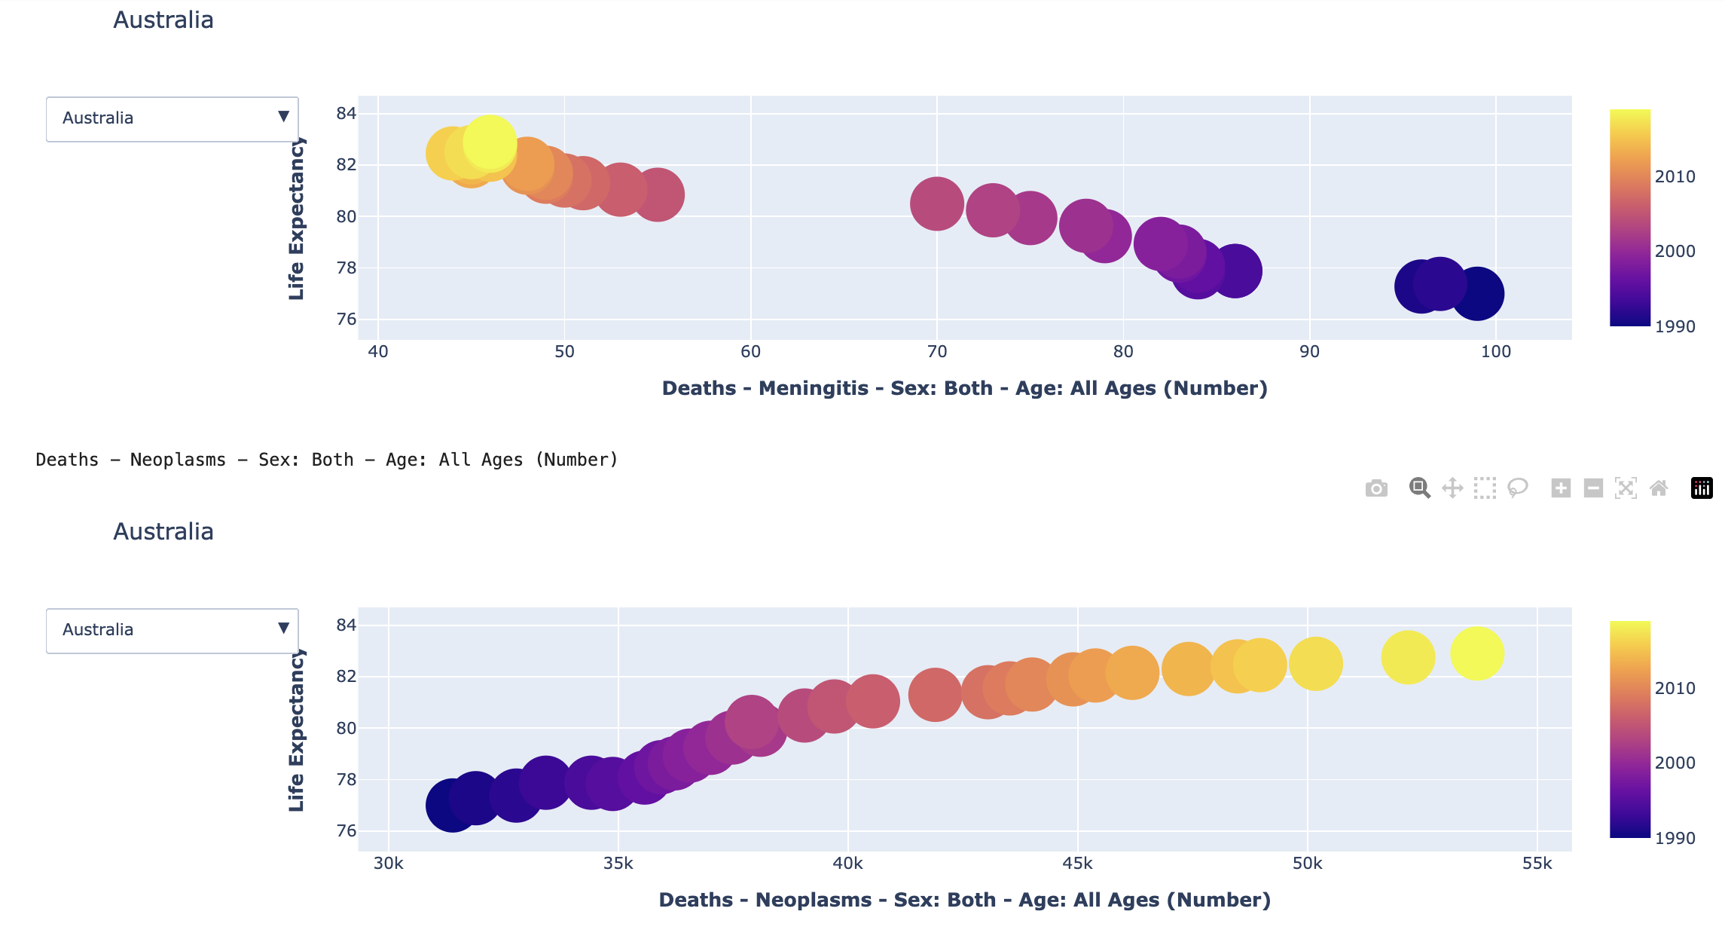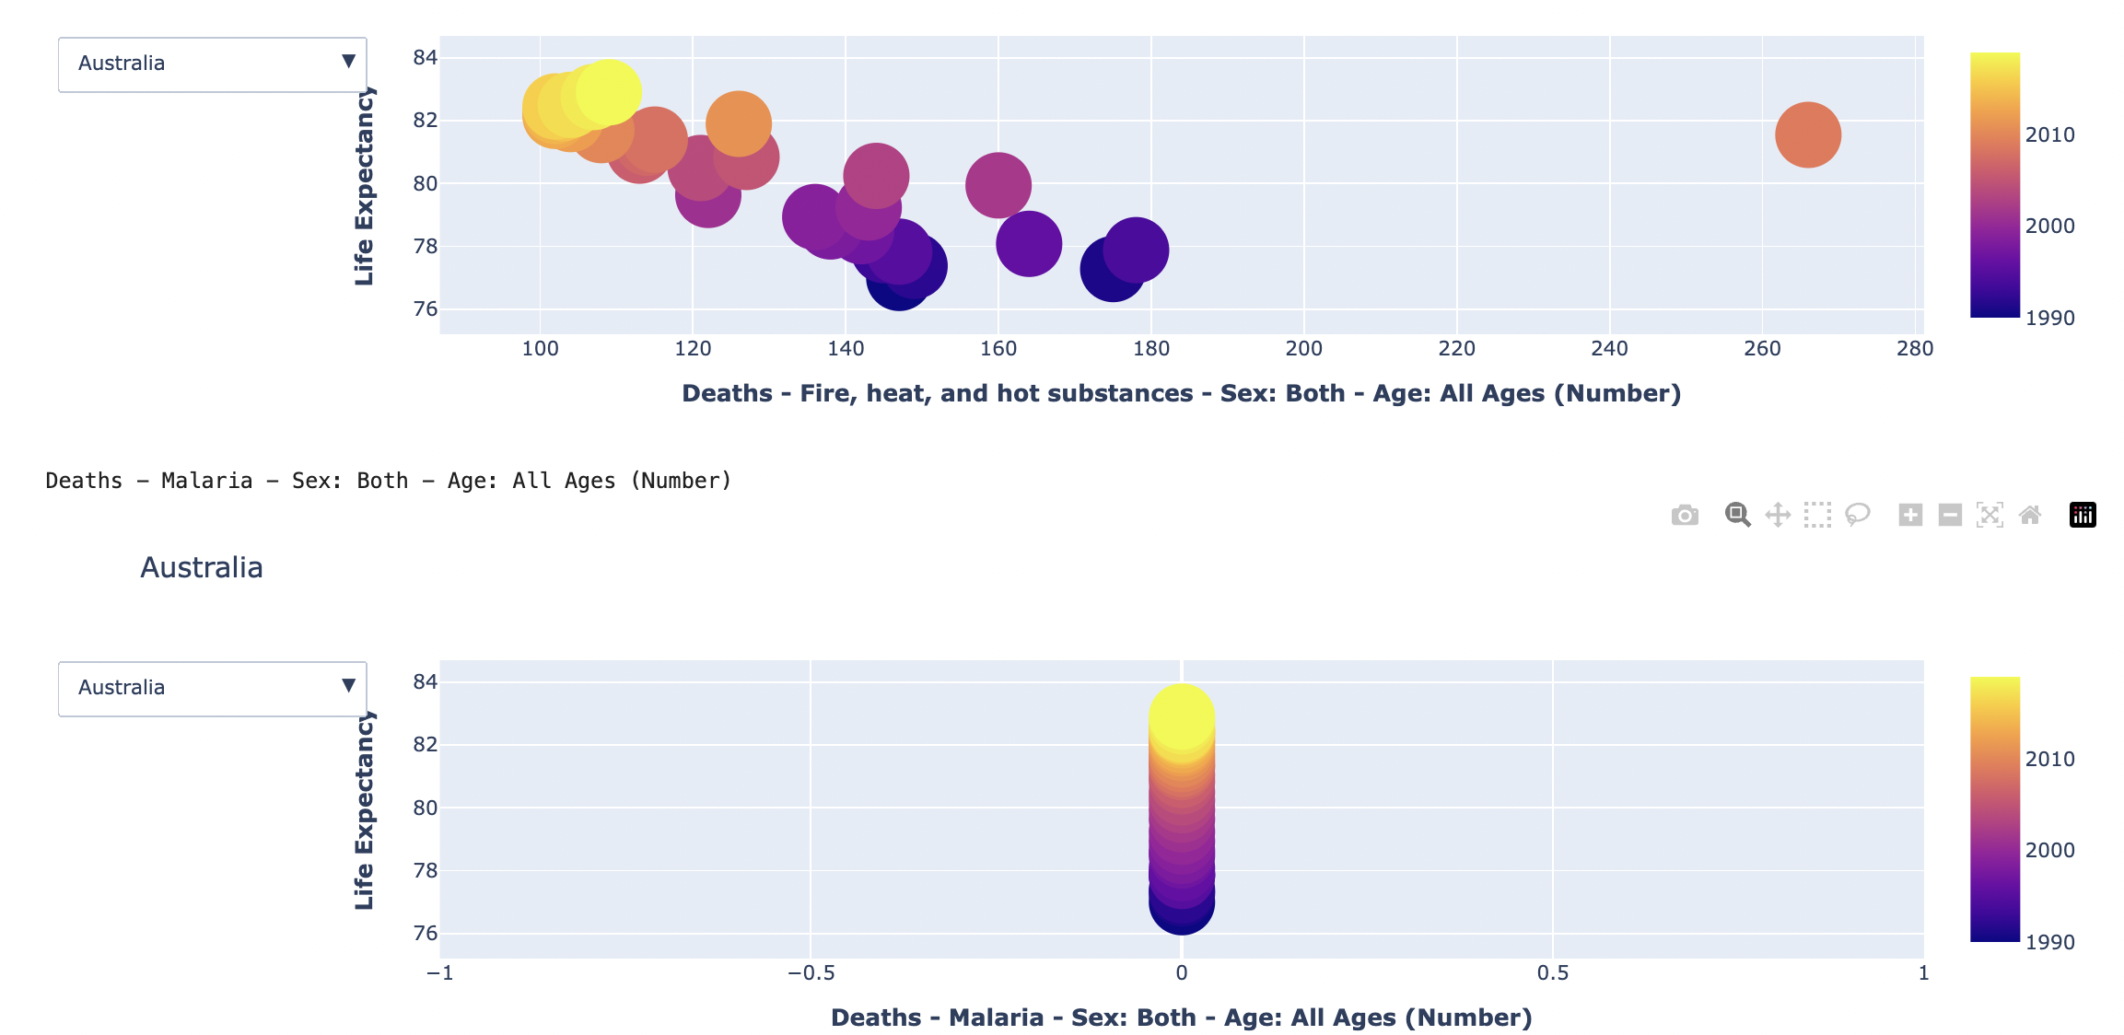

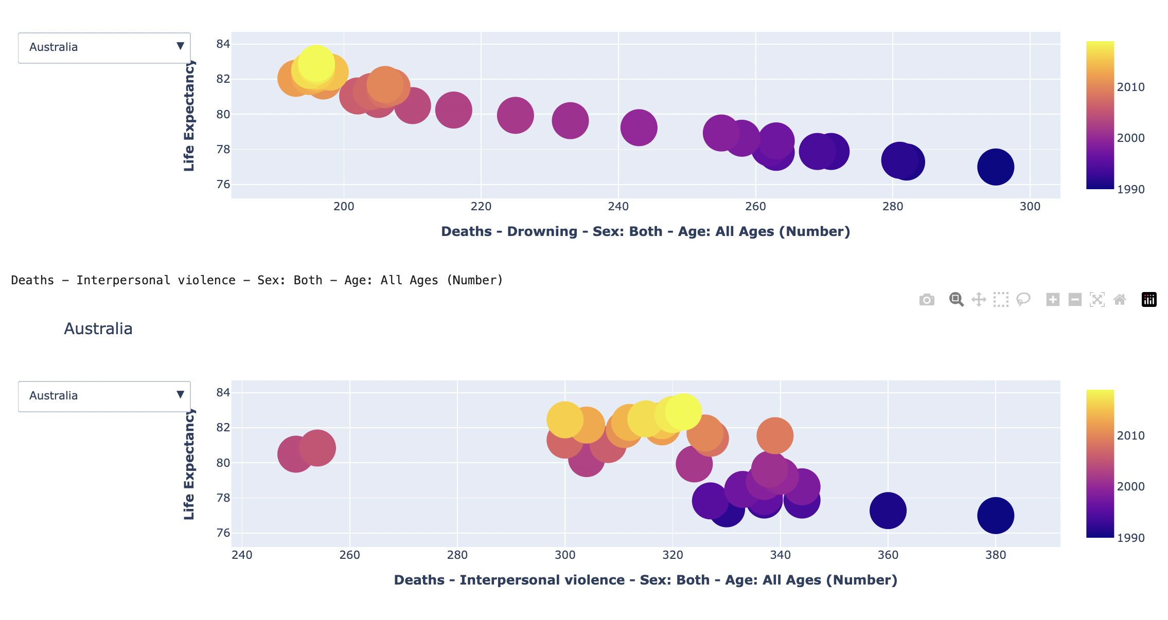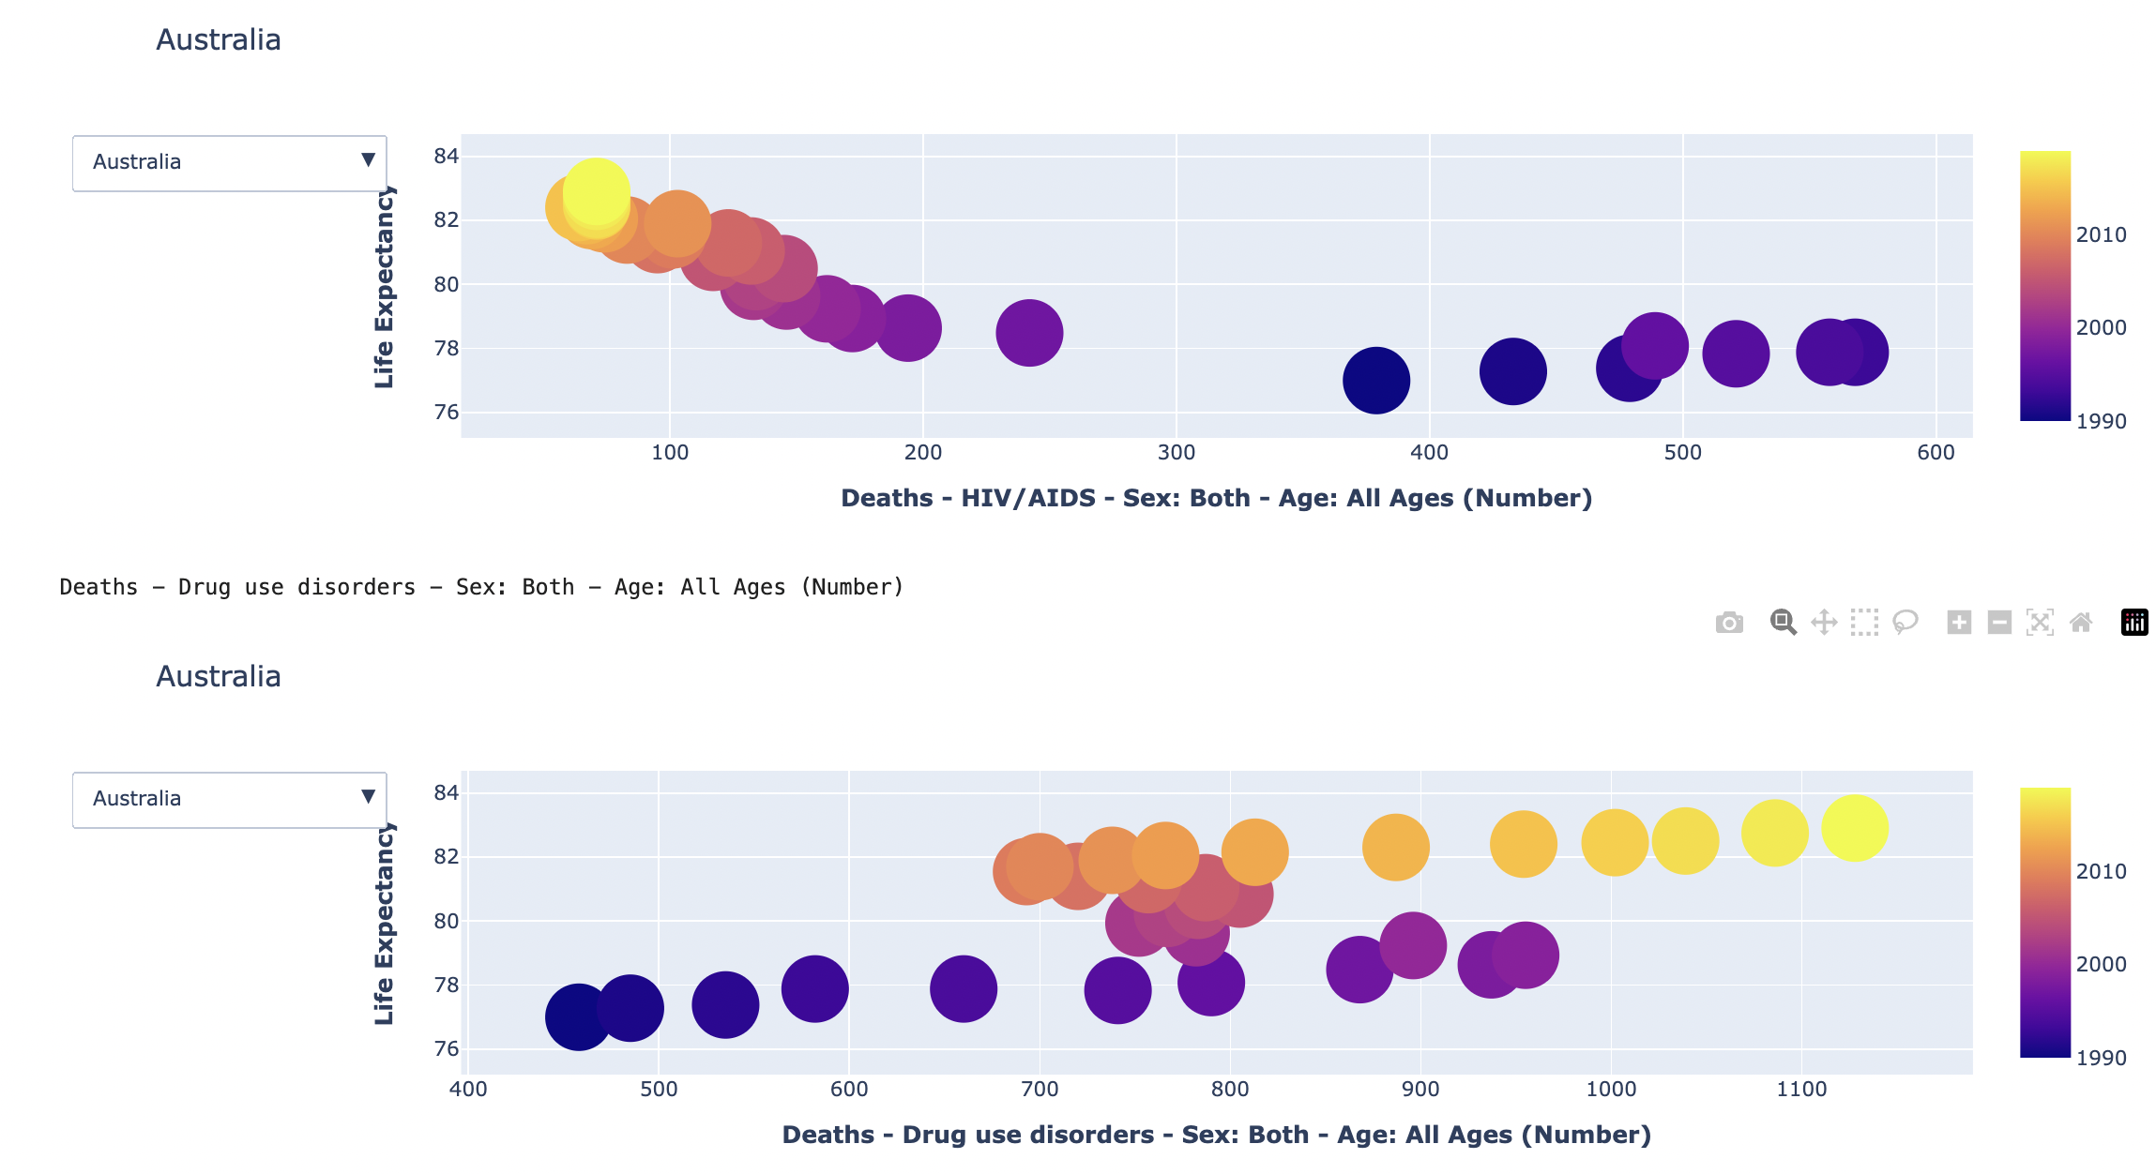

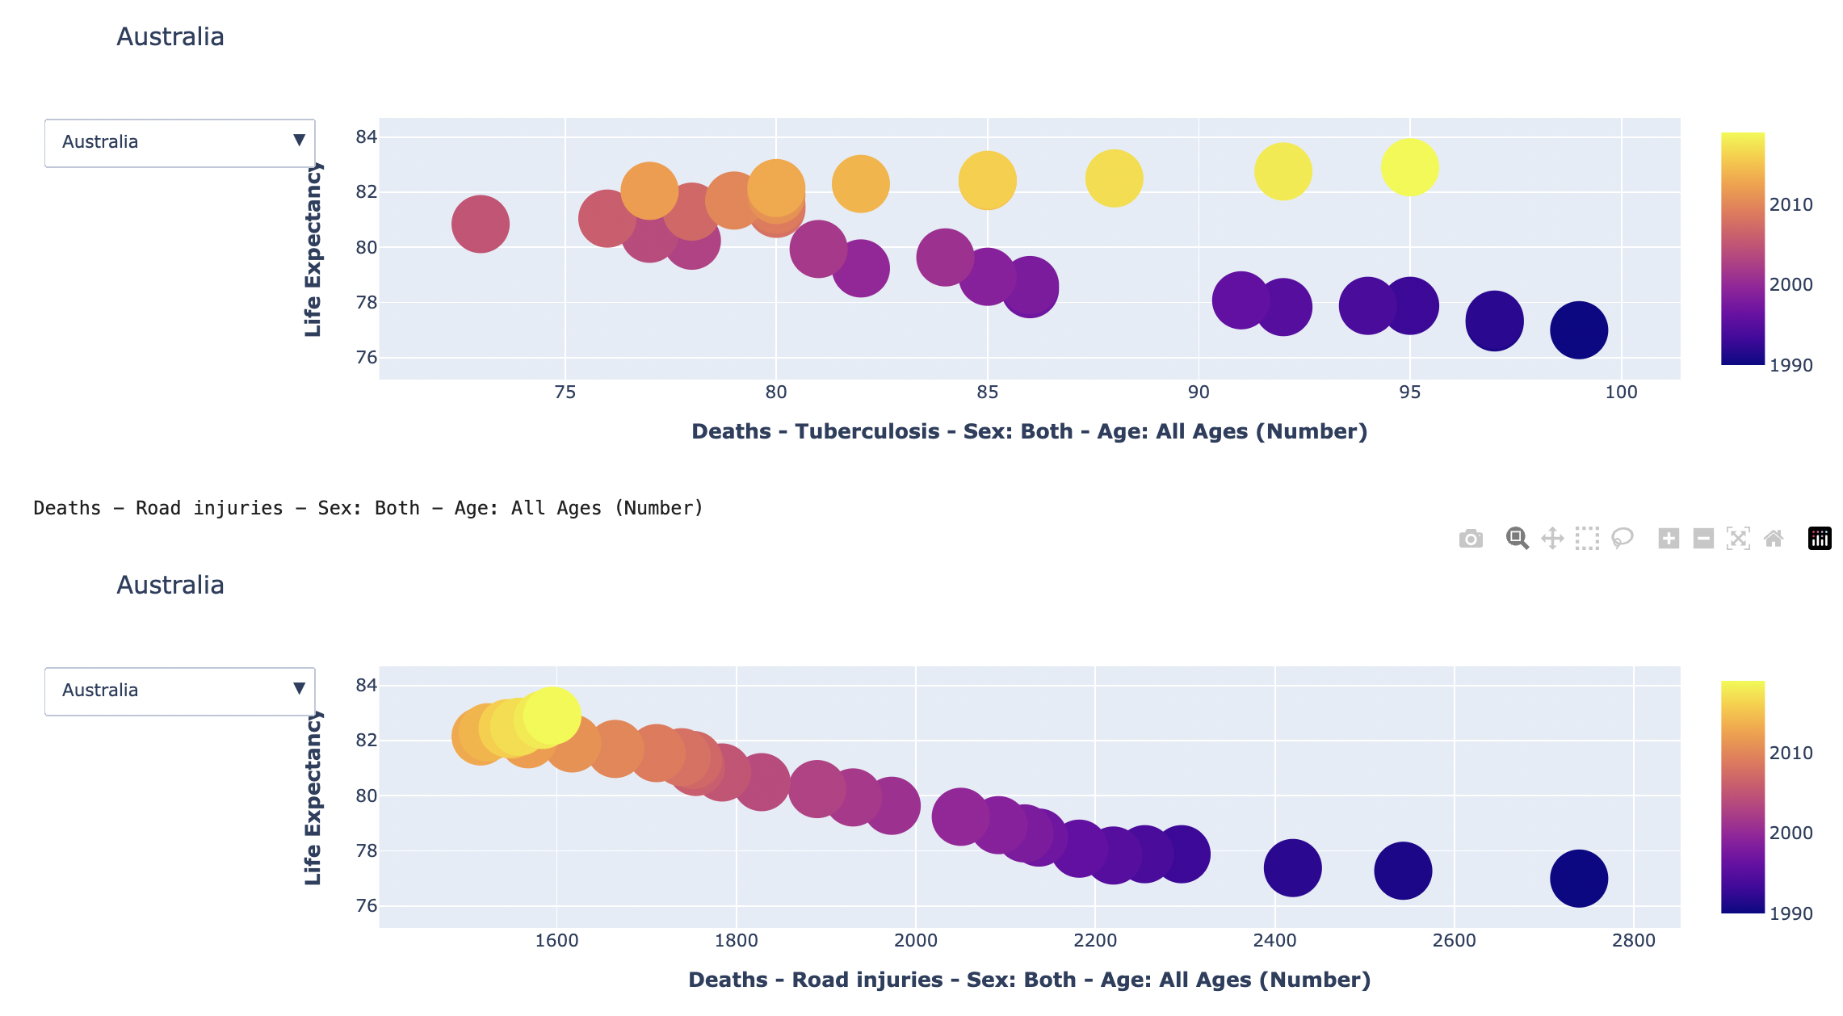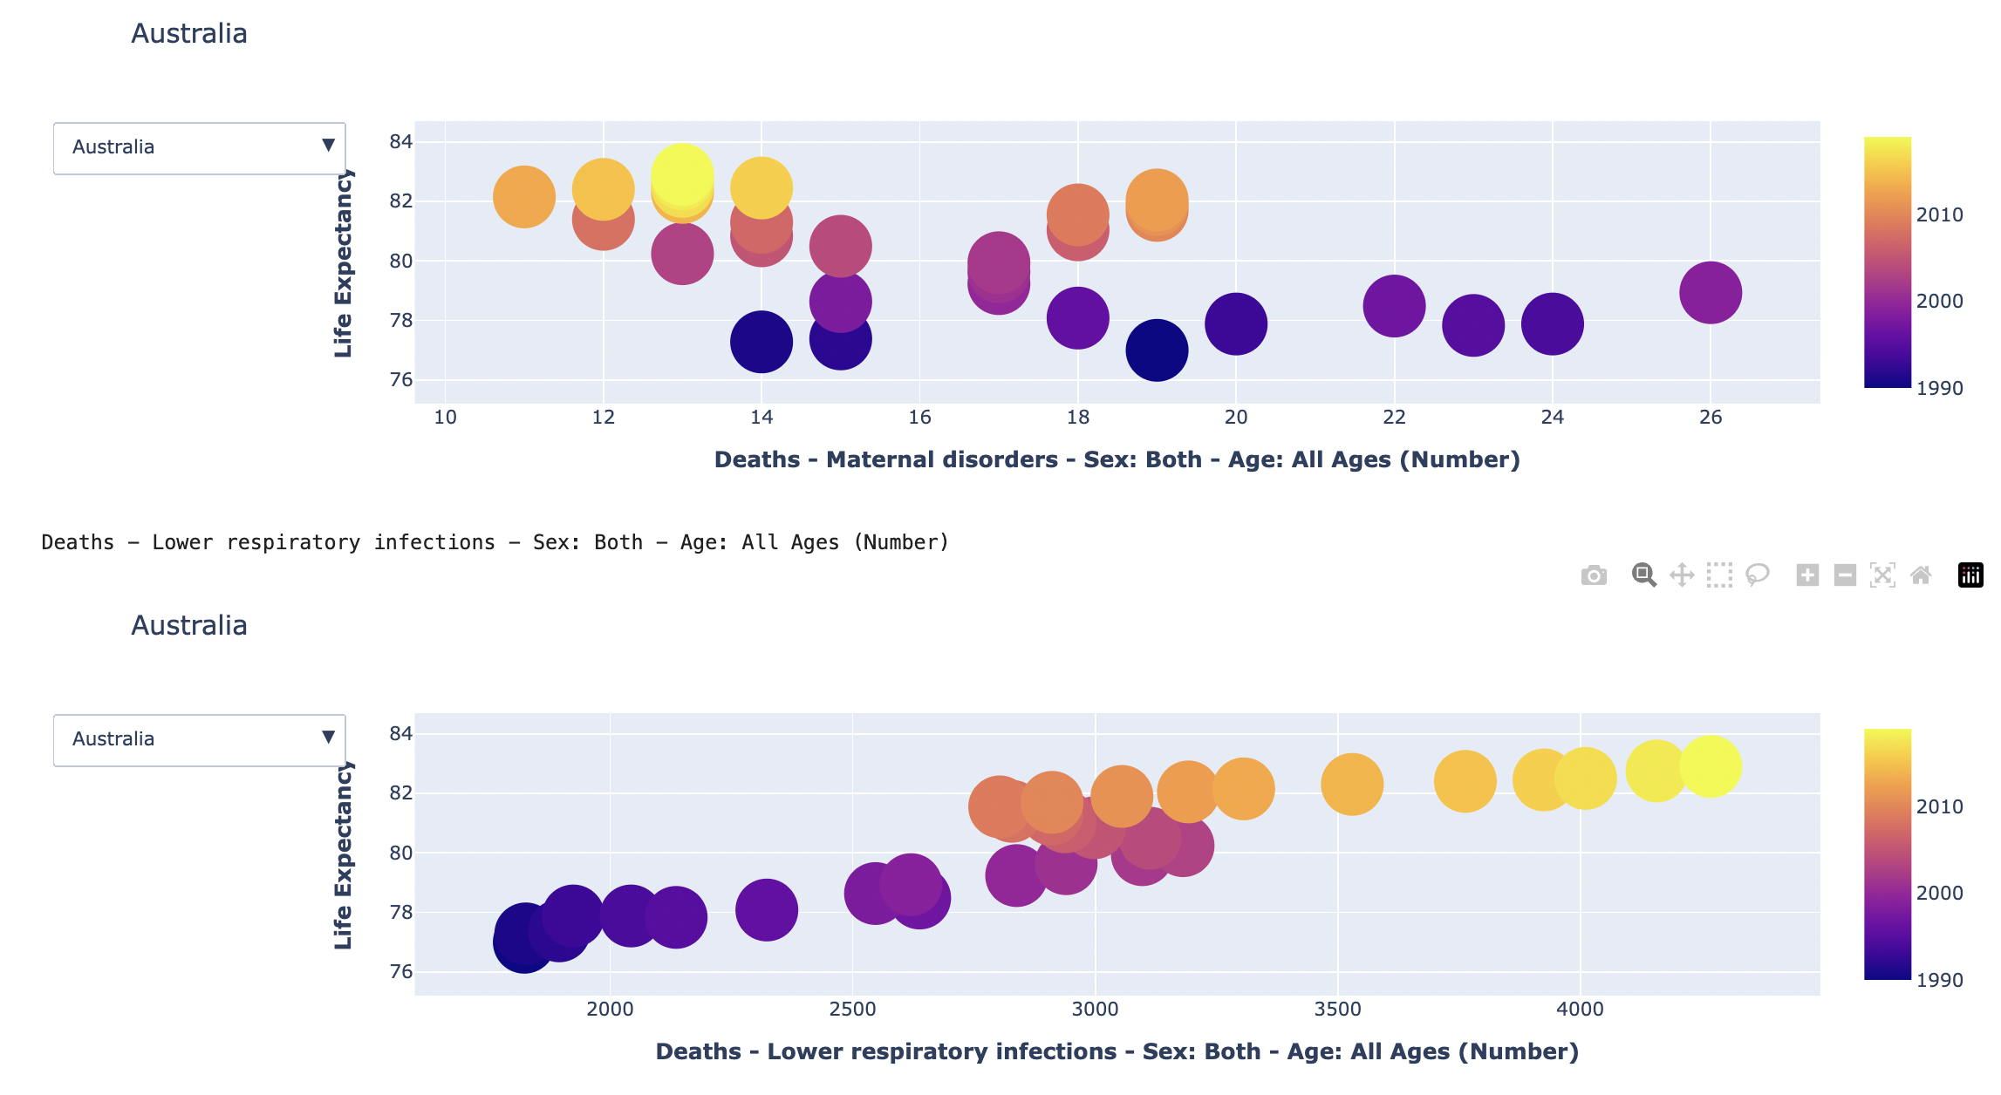 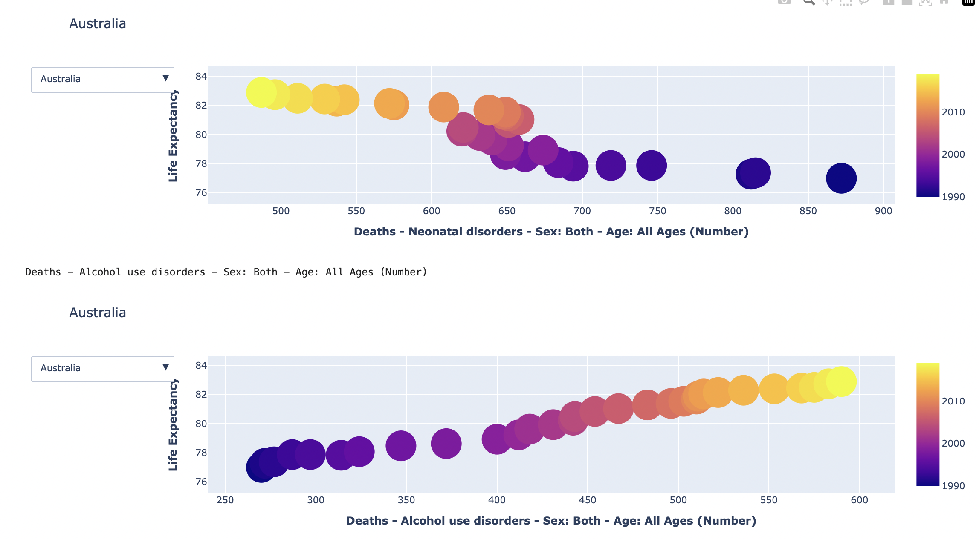 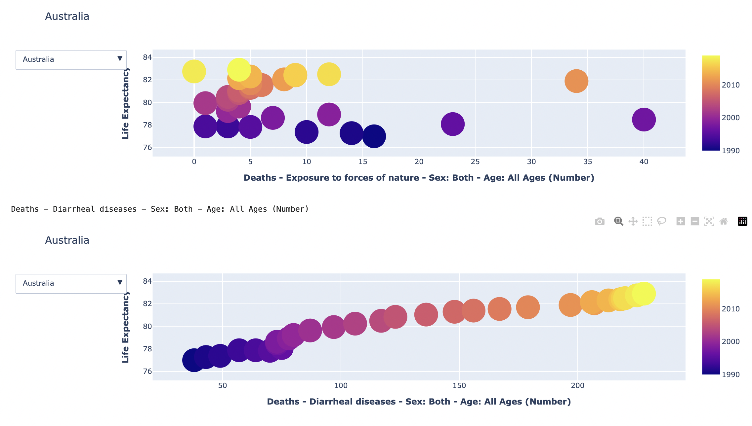 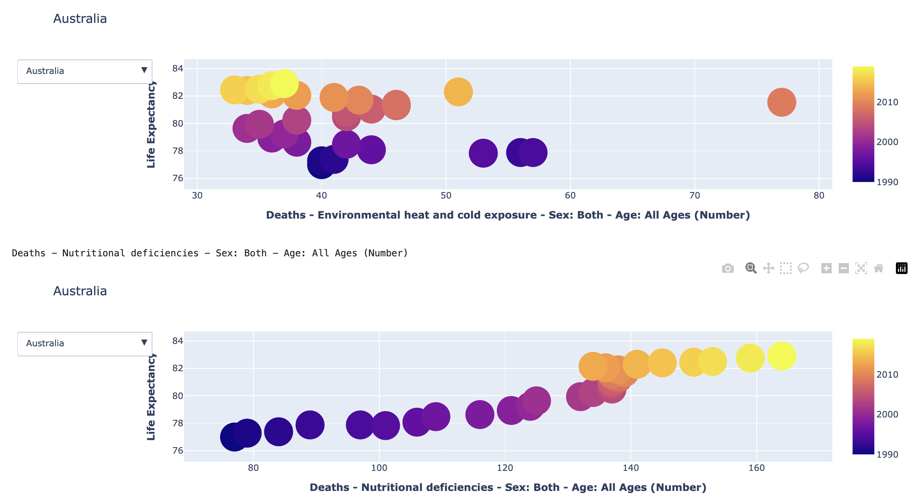 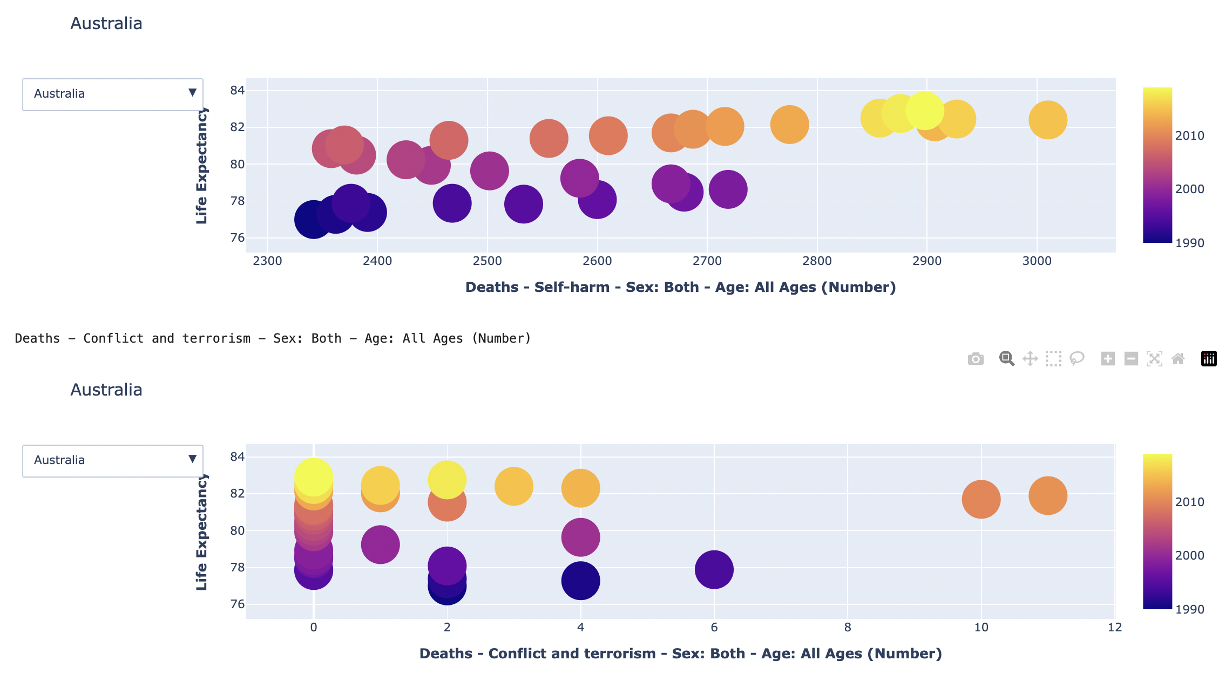 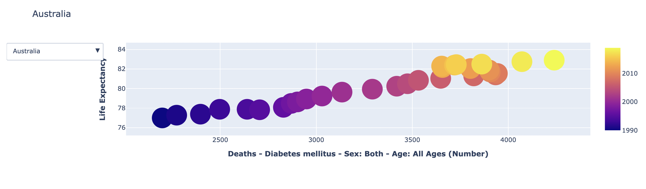

## Feature Selection

## Model Training

Classical Machine Learning regression models are employed to predict the life expectancy. The proposed methodology makes use of Multiple Linear Regression, Decision Tree Regression, Support Vector Machine, Elastic Net Regression and Gradient Boosting Regression models. Candidates are generated exhaustively from a grid of parameter values specified with the cross-validation score function using the grid search offered by GridSearchCV. This helps in optimizing and tuning the hyperparameters of the classical machine learning regression models.

## Model Validation

| Regression Model | RMSE |
| --- | --- |
| Multiple Linear Regression | 0.3028 |
| Support Vector Machine | 0.3043 |
| Decision Tree Regression | 0.2167 |
| Elastic Net Regression | 0.7516 |
| Gradient Boosting Regression | 0.1670 |

# Results (1000 Words)

# Conclusion (1100 Words)

(Take Home Message)

Discussion

Project Limitation

This study provides a thorough examination of recent life expectancy trends in a set of high-income as well as low-income countries using data from WHO/World Bank and consistent methodology.

Diseases which can often go undetected such as Pneumonia, Influenza, Chlamydia, Huntington’s etc. may be unreported on death certificates. These diseases go undetected owing to lack of diagnostic testing. Consider the cases of influenza and pneumonia, which frequently go undiagnosed and can raise the risk of dying from cardiovascular illnesses and other respiratory diseases, which are finally listed as the cause of death on the death certificates. The severity of this underreporting increases with age. We try to solve this issue by utilizing a more inclusive category for causes of death: "Deaths - Chronic respiratory disorders."

Even though life expectancy is a widely used and intuitive summary measure of population health, other measures of health and wellbeing also take other aspects of health and quality of life into account. These measurements, which aim to account for years lived in good health without the experience of illness, disability, or functional limits, include health adjusted life expectancy, disability-free life expectancy, healthy active life expectancy, and disability-adjusted life expectancy. We are currently not examining these measures in this study.

Stakeholder Analysis

# **Acknowledgments**

Team India would like to express its gratitude and huge pride to our respected instructors Dr. Kyle Zawada and Dr. Jarod Lee for giving us this wonderful platform so that we could all come together to learn and explore the fantastic curriculum you have provided us with this semester.

We have found inspiration in you guys, and your knowledge and experience have assisted us in learning and giving this assignment the form it has taken. The success of this research would not have been as great without your oversight and direction.

Successfully completion of any type of project and to complete it within the given timeframe requires the efforts and co-operation from all its group members. Team India sincerely appreciates the time and hard work each individual group member has put in for the execution of this project.

# References

# Appendix